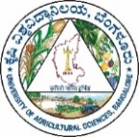
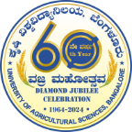
DIRECTORATE OF EXTENSION, GKVK
UNIVERSITY OF AGRICULTURAL SCIENCES BANGALORE - 65

Director of Extension

No.DE/SO/MPR/2025-26/ Date: 04.07.2025

N O T E

Sub: | Submission of Monthly Progress Report for the month of June -2025 from the Directorate of Extension, GKVK, UAS, Bangalore– reg.
***

Monthly progress report of the Directorate of Extension, UAS, Bangalore for the month of June -2025 is enclosed herewith for your kind perusal and further needful.

Director of Extension

To
The Coordinator,
PPMC, GKVK, UAS
Bangalore-65.

Copy submitted to

The Secretary to the Vice-Chancellor, GKVK,UAS(B) for information

Directorate of Extension, GKVK, Bangalore -560 065
Email: deuasbangalore@gmail.com, Mo: 9449866904, Office: 23418883
Monthly progress report of the Directorate of Extension, UASB for the month of
June -2025

- PROGRESS OF UNITS
- Staff Training Unit (STU), GKVK

Progress of DAESI Batch -8, TP No. 2881 weekly classes
Sl. No. | Week | Date | No. of Participants
1 | 32nd Week | 09-06-2025 | 31
2 | 33rd Week | 16-06-2025 | 33
3 | 34th Week | 23-06-2025 | 33
4 | 35th Week | 30-06-2025 | 34

a) SAMETI (South)

i) DAESI: Diploma in Agricultural Extension Services for Input Dealers Activities

Sl. No. | District | Completed During the Month |  | Ongoing  Batches |  | Started During  the Month
 |  | No of Batches | No of Input dealers | No of  Batches | No of Input dealers | No of  Batches | No of Input dealers
1 | Bengaluru | - | - | 4 | 160 | - | -
2 | Chamarajnagara | - | - | 1 | 40 | - | -
3 | Chickballapur | - | - | 3 | 120 | - | -
4 | Chikkamagaluru | - | - | 1 | 40 | - | -
5 | Chitradurga | - | - | 4 | 160 | - | -
6 | Dakshina Kannada | - | - | 2 | 80 | - | -
7 | Davanagere | - | - | 3 | 120 | - | -
8 | Hassan | - | - | 6 | 240 | - | -
9 | Kodagu | - | - | 1 | 40 | - | -
10 | Kolar | - | - | 3 | 120 | - | -
11 | Mandya | - | - | 2 | 80 | - | -
12 | Mysuru |  |  | 4 | 160 | - | -
13 | Shivamogga | 1 | 39 | 1 | 40 | - | -
14 | Tumkur | - | - | 4 | 160 | - | -
15 | Ramanagara | - | - | 2 | 80 | - | -
Total |  | 1 | 39 | 41 | 1640 | - | -

- Farmers Training Institute (FTI), GKVK:
- Training Programs for TPMs under Sanjeevini- KSRLPS
Sl.  No. | Date | Title | Duration | No. of  Trainees
01 | 02-06-2025 to  06-06-2025 | Sanjeevini – KSRLPS Taluk Programme Managers Training on NRLM Programme Implementation | Five days | 80
02 | 16-06-2025 to  20-06-2025 |  |  | 51
03 | 23-06-2025 to  27-06-2025 |  |  | 47
Total |  |  |  | 178

- Training program in collaboration Microbiology Department, UAS, GKVK, Bangalore
Sl.  No. | Date | Title | Duration | No. of  Trainees
01 | 23-06-2025  to  27-06-2025 | Mushroom Production Technologies | Five days | 23

- Institute of Baking Technology and Value Addition (IBT & VA)

- Training programmes organized
Sl. No | Title | No. of Programmes. | Date | No. of Parti.
1 | Four weeks Baking Course | 1 | Completed  02.06.25 to 27.06.25 | 26
2 | 14 Weeks Certificate Course on Bakery Technology | 1 | Under progress  (02.04.2025 to 9.07.2025) | 39
3 | Short courses
 | Basics of baking | 01 (4 days) | 09.06.25 to 13.06.25 | 14
 | Value added Eggless Bakery Products & Fancy breads and rolls | 02 (3days) | 04.06.25 to 06.06.25 24.06.25 to 26.06.25 | 13  17
 | Value added Amla products | 01 (2days) | 18.06.25 and 19.06.25 | 28
 | Total | 04 | - | 72
4 | One day Workshop
 | Digital Marketing and Financial Support by Government schemes | 1 | 19.06.2025 | 150
5 | Collaborative Training programme
 | Home baking | 01 | 04.05.25 to 06.06.25 | 20
 | Basics of baking | 01 | 09.06.25 to 13.06.25 | 36
 | Total | 02 | - | 56
6 | Orientation programmes
 | One day orientation programme on Activities of Institute, Introduction to baking Industry. Hands on training of coconut cookies and method demonstration of Sponge cake | 02 | 11.06.25 & 26.06.25 | 160

b) Total production of bakery and value added products are as follows.

1. Bakery products

Sl. No | Particulars | Total | Amount (Rs)
1. | Bread (Nos) | 837.0 | 25110.0
2. | Bun (Nos) | 2326.0 | 13950.0
3. | Biscuits/Rich Biscuits (Kgs) | 341.0 | 85250.0
4. | Cakes/Rich cupcakes (Nos) | 6769.0 | 67690.0
5. | Cakes/Rich cakes (Kgs) | 92.0 | 23.000
6. | Special products (Nos) | 2988.0 | 35856
 | Total | 12920 Nos  433 Kgs | 2,15,000

2. Value added products
Sl. No | Particulars | Total | Amount (Rs)
1. | Ragi based products (Kgs) | 48.3 | 14,490.0
2. | Nutri rich flax seed ladoos (Kgs) | 26.0 | 7,800
3. | Millet based products (Kgs) | 28.50 | 9,975
 | Grand Total (Kgs) | 102.8 | 32,265

c) Extension activities:

Sl.  No. | Title of the Extension Programme | No of Programmes | No. of Participants |  | Total
 |  |  | Male | Female
1 | Method/ Skill demonstrations Organized | 10 | 98 | 253 | 351
6 | Advisory services
 | Face to face contact (No’s) | 424 | 169 | 255 | 424
 | Telephone calls (No’s) | 528 | 234 | 294 | 528
8 | Important days
 | Organized | 03 | 85 | 130 | 215
9 | Important events
 | Organized | 01 | 60 | 90 | 150
 | Participated | 05 | 19 | 28 | 47
10 | Served in different committees
 | As Member | 01 | -- | 01 | 01
11 | Melas /Exhibitions
 | Organized | 01 | 15 | 24 | 39
 | Participated | 01 | 02 | 02 | 04
12 | No. of visitor visited the institute (No’s) | 530 | 212 | 318 | 530
13 | WhatsApp queries answered  (No’s) | 416 | 166 | 250 | 416
14 | Any other (Specify)  Meeting participated | 01 | -- | 01 | 01

- Farm Information Unit (FIU), GKVK

Sl. No. | Activity | No.
 | Press Visits | 15
 | Press Release | 14
 | Press Meet | 1
 | Press Coverage’s | 53
 | Popular / Success Stories Published | 5
 | Special Articles Published in News Papers | 4
 | Co-Ordination to TV & Radio Programmes for Telecast / Broadcast | 8
 | Co-Ordination to Media Persons for Special Articles | 4

- Distance Education Unit (DEU), GKVK
  - One Year Diploma in Agriculture
- Evaluation of answer booklets of 2nd semester One Year Diploma (Agriculture) 2024-25 batch is under progress
- 186 candidates has been registered for One Year Diploma (Agriculture) for the academic year 2025-26
- Study material of first semester subjects will be dispatched in the month of July for the registered candidates

2. Post Graduate Diploma in Agriculture (PGDA)
- Evaluation of answer booklets of 2nd semester PGDA 2024-25 batch is under progress
- Study material of first semester subjects will be dispatched in the month of July for the registered candidates
Certificate Courses

1. Organic Farming (Postal)
- For the year 2024-25, Chapter 12- “¸ÁªÀAiÀÄªÀ PÀÈ¶AiÀÄ DyðPÀvÉ” has been dispatched for the 27 registered candidates
- 27 candidates has registered for Organic Farming certificate course for the academic year 2025-26
- Study material (Chapter 1) will be dispatched in the month of July for the registered candidates
2. Beekeeping course
- 15 candidates has been registered for the Bee Keeping certificate course for the academic year 2025-26
- Study material will be dispatched in the month of July for the registered candidates

6. Agricultural Technology Information Centre (ATIC), GKVK

The center has realized an amount of Rs. 30,54,058/- (Rupees Thirty lakh fifty four thousand fifty eight only) through the sale of critical inputs like seeds, planting materials etc. and performed following services:
- Sale of books/booklets/publications, CD’s and other inputs
Sl.  No. | Particulars | Qty /Kgs/Nos. | Amount (Rs.)
1 | Publications - nos | 207 | 26,508
2 | Planting Material - nos | 14925 | 25,17,540
3 | Manure - kgs | 8153 | 2,15,213
4 | Nutrient mixture - kgs | 50 | 8,880
5 | Bio-agents - kgs/ltr | 6 | 10,240
6 | Bio-fertilizer- kgs | 63 | 6,930
7 | Nursery equipment’s - nos | 1352 | 1,97,092
8 | Seeds
 | IIHR Seed kit - nos | 09 | 2,250
 | IIHR Seed packets - nos | 186 | 7,310
 | Vegetable/Flower seeds - nos | 1866 | 62,095
Total |  |  | 30,54,058

- Extension activities:
Sl.No. | Title | No. of Participants
1 | Telephone calls received | 80
2 | Consultations | 288
3 | Farmers/Extension personnel visit | 9189
4 | Whats App queries answered | 135
5 | Agri-Portal viewers | 62345

7. Agricultural Science Museum

Sl. No. | Particulars | No. of visitors
1 | Farmers | 46
2 | Students | 573
3 | Other public visitors | 52
Total |  | 671

8. Extension Education Units (EEUs)
- Demonstartions

Sl. No. | Title | EEU, Kolar | EEU, Naganahalli | Total
1. | Front Line Demonstration
 | a) No. | 2 | 16 | 18
 | b) Area (ha./units)/Animals | 12 | 6.4 | 18.4
 | c) No. of farmers | 30 | 16 | 46

- Details of Extension activities carried out

Sl.  No. | Details of Extension Activities Carried out (Nos.) | EEU, Kolar |  | EEU,  Naganahalli |  | Total
 |  | Prog. | Part. | Prog. | Part. | Prog. | Part.
 | On-campus | - | - | 2 | 435 | 2 | 435
 | Collaborative Prog. | 4 | 108 | 5 | 265 | 9 | 373
 | Sponsered training prog | - | - | 2 | 65 | 2 | 65
 | Resource person (Guest Lectures) | - | - | 2 | 71 | 2 | 71
 | Field visits by KVK scientists | 13 | 40 | 16 | 43 | 29 | 83
 | Consultancy through telephone | 16 | 16 | 12 | 12 | 28 | 28
 | Consultancy through face to face | 8 | 17 | 2 | 30 | 10 | 47
 | Group Discussion meetings | 3 | 41 | 8 | 48 | 11 | 89
 | Diagnostic Field visits | - | - | 38 | 76 | 38 | 76
 | Newspaper coverage | 1 | - | 4 | - | 5 | -
 | Radio Programme | - | - | 1 | - | 1 | -
 | Exhibition & Krishimelas organized | - | - | 1 | - | 1 | -
 | Exposure visits organized | 1 | 50 | 2 | 65 | 3 | 115
 | Important events organized | 1 | 21 | 2 | 435 | 3 | 456
 | Special day celabaration | - | - | 1 | 67 | 1 | 67
 | Method demonstrations conducted | 4 | 108 | 6 | 228 | 10 | 336
 | What’s app SMS | 16 | 415 | 30 | 150 | 46 | 565
 | DAESI class conducted during the month | - | - | - | 80 | - | 80
 | RSKs visit | 2 | 31 | - | - | 2 | 31

9. National Agricultural Extension Project (NAEP), Bangalore/Mandya
Sl.  No. | Title | No. of progs.
 |  | ADE, GKVK, Bangalore | ADE,  Mandya
1 | Number of Districts under the Jurisdiction | 05 | 05
2 | Number of Bimonthly workshops organized | 02 | 02
3 | Report on the conduct of Bimonthly training programmes sent | 02 | 02
4 | Training program participated | 06 | 00
5 | Participation in special day/ event celebration | - | 01
6 | Field visits | 05 | 00
7 | Field problem noticed | 20 | 01
8 | Radio/TV programs | 02 | 00
9 | Meeting attended | 05 | 03
10 | Major guide to M.Sc/ Ph.D | 04 | 02*
11 | Consultancy Services / Farmers visit | 65 | 60
*M.Sc: 02

10. Krishi Vigyan Kendras (KVKs): The following activities were carried out by KVKs of UASB

Sl.No. | Activity | Name of the KVK |  |  |  |  |  |  | Total
 |  | BRD | TMK | HSN | CNR | RNR | CBP | MND
1 | On Farm Testing (OFT )
 | a) No. | - | - | - | - | 2 | - | 2 | 4
 | b) Area(ha./units) | - | - | - | - | 2 | - | 0.42 | 2.42
 | c) No. of farmers | - | - | - | - | - | - | 10 | 10
2 | Front Line Demonstration
 | a) No. | 1 | 3 | 1 | 1 | 6 | - | - | 12
 | b) Area (ha./units)/Animals | 2 | 6 | 0.1 | 2 | 20 | - | - | 30.1
 | c) No. of farmers | 10 | 25 | 3 | 10 | - | - | - | 48
3 | Publications (Nos.)
 | a) Popular articles | 1 | - | 2 | - | 1 | - | - | 4
 | b) Research papers | 2 | - | - | - | - | - | - | 2
 | c) Folder | 2 | - | - | - | - | - | - | 2
4 | SWTL ( No. of Samples analysed)
 | a. Soil | 15 | 33 | 11 | 21 | 27 | 1 | 18 | 126
 | b. Water | 9 | - | - | 17 | 33 | 5 | 19 | 83
 | e. Micro nutrients | - | 33 | - | - | 5 | - | - | 38
5 | Bio-agents
 | Pseudomanas (Kgs.) | - | 10 | 97 | 221 | 36 | - | 18 | 382
 | Trichoderma (Kgs.) | - | - | 78 | 231 | 40 | - | 28 | 377
 | AMC powder (Kgs.) | - | 45 | - | - | - | - | - | 45
 | Waste Discomposer (Nos.) | - | 1 | - | - | 4 | - | - | 5
 | Paecilomyces (ltrs) | - | - | - | 180 | - | - | - | 180
 | Metarhizium (ltrs) | - | - | 28 | 75 | - | - | - | 103
 | Neem Soap (kgs) | - | - | 6 | - | - | - | - | 6
 | Waste decomposer | - | 1 | - | - | - | - | - | 1
6 | Micro Nutrients mixture (kgs.)
 | Vegetable Special | - | - | 4 | 36 | 6 | 14 | - | 60
 | Banana Special | - | - | 46 | 168 | 8 | - | 45 | 267
 | Ginger Special | - | 2 | 93 | - | - | - | - | 95
 | Turmeric Booster | - | - | - | 25 | - | - | - | 25
 | microbial consortia | - | - | - | - | 35 | - | - | 35
 | Ginger rich | - | - | 84 | - | - | - | - | 84
 | Pepper Special | - | - | 2 | - | - | - | - | 2
7 | Seeds (Kgs.) | - | 175 | 415 | 70 | 211 | 245 | - | 1116
8 | Seedlings (Nos.) | 802 | 1095 | 803 | 344 | 958 | - | - | 4002
9 | Fodder Slips/cutting (Nos./Kg) | 25 | - | - | - | 375 | - | - | 400
10 | Fodder seeds (kgs.) | - | 13.5 | 6.5 | - | 18.5 | 22 | - | 60.5
11 | Live stock (Nos.)
 | Milk (ltrs) | - | - | 380 | - | - | 82 | - | 462
 | Chicks | - | - | 495 | - | 4 | - | - | 499
 | Ginifoul | - | - | 3 | - | - | - | - | 3
12 | Equipments (Nos.)
 | Mango harvester | - | - | - | - | 2 | - | - | 2
13 | Azolla (kg) | - | - | - | - | 4 | - | - | 4
14 | Earthworm(kgs.) | - | - | 1 | - | 1 | - | - | 2
15 | Value added Products
 | Honey (kg) | - | - | - | 11 | - | - | - | 11
 | Ragi malt | - | 0.5 | - | - | - | - | - | 0.5
16 | Millets processed at KVK milltes processing unit
 | Haraka (kg.) | - | 9 | - | - | 21 | - | - | 30
 | Saame (kg.) | - | 11 | - | - | - | - | - | 11
 | Ragi (Kg.) | - | 13 | - | - | 56.5 | - | - | 69.5
17 | Farm produce(kg/No.)
 | Mango fruits (kg) | 250 | 650 | 140.74 | 230 | 1892.5 | - | - | 3163.24

Four On Farm Testing (OFTs) on Assessment on Paired row planting in redgram for mechanized cultivation, Ecofriendly management of fruit flies in Ridge gourd, Sulphur nutrition on growth and yield of small onion and Foliar micronutrient management on fruit yield of Banana Cv. Elakki in 2.24 ha. involving 10 farmers and 12 Front Line Demonstrations (FLD) Demonstration of High yielding Tuberose hybrid – Arka Prajwal, Bio formulations for improving quality and management of diseases in Pomegranate, Eco friendly Management of Kitchen Waste and its usage for Home Gardening, Popularization of NARI Nirbeeja grafts of Subabul for nutritious fodder, Demonstration of foxtail millet variety GPUF-3, Integrated crop management in paddy, High yielding white seeded sesame (variety–GKVKS-1) for additional returns during pre-kharif, High yielding Castor Hybrid-ICH66 for higher yield and returns, Management of spindle bug in Arecanut, Eco friendly management of fall armyworm in fodder maize and Eco friendly management of pests in mulberryin an area of 30.1 ha involving 48 farmers.

- Details of Extension activities carried out
Sl.No. | Details of Extension Activities Carried out (Nos.) | BRD |  | CBP |  | RNR |  | CNR |  | TMK |  | MND |  | HSN |  | Total
 |  | Prog. | Part. | Prog. | Part. | Prog. | Part. | Prog. | Part. | Prog. | Part. | Prog. | Part. | Prog. | Part. | Prog. | Part.
 | On-campus | 2 | 95 | 1 | 55 | - | - | 1 | 300 | - | - | 4 | 125 | - | - | 8 | 575
 | Off-campus | 2 | 210 | 1 | 30 | - | - | - | - | 4 | 100 | 12 | 433 | 11 | 623 | 30 | 1396
 | Extension functionaries | 1 | 34 | - | - | - | - | - | - | - | - | - | - | - | - | 1 | 34
 | Collaborative Prog. | - | - | - | - | - | - | - | - | - | - | 1 | 53 | - | - | 1 | 53
 | Resource person (Guest Lectures) | 9 | 399 | 4 | 72 | 3 | 400 | 60 | 9200 | 2 | 895 | 8 | 413 | 60 | 6468 | 146 | 17847
 | Field visits by KVK scientists | 3 | 53 | 28 | 137 | 76 | 100 | 12 | 185 | 1 | 30 | 41 | 212 | 9 | 360 | 170 | 1077
 | Consultancy through telephone | 726 | 726 | 45 | 45 | 1617 | 1617 | 1096 | 1096 | 289 | 289 | 179 | 179 | 212 | 212 | 4164 | 4164
 | Consultancy through face to face | 4438 | 4438 | 91 | 91 | 915 | 915 | 623 | 623 | 156 | 156 | 358 | 358 | 586 | 586 | 7167 | 7167
 | Group Discussion meetings | 1 | 25 | 24 | 315 | - | - | 60 | 9200 | 1 | 200 | 47 | 5245 | - | - | 133 | 21842
 | Diagnostic Field visits | 2 | 8 | - | - | 2 | 18 | - | - | 6 | 65 | - | - | 2 | 25 | 12 | 116
 | Newspaper coverage | 8 | - | 30 | - | 8 | - | 58 |  | 6 | - | 18 | - | 32 | - | 160 | -
 | Film show organized | 1 | - | - | - | - | - | - | - | - | - | 3 | - | - | - | 4 | 222
 | TV programme | 2 | - | - | - | 6 | - | - | - | - | - | 7 | - | 8 | - | 23 | -
 | Radio Programme | 1 | - | 1 | - | - | - | 2 |  | - | - | 2 | - | 11 | - | 17 | -
 | Exhibition & Krishimelas organized | 1 | - | - | - | 1 | - | 30 | 6200 | - | - | 16 | - | - | - | 48 | 14540
 | Exhibition & Krishimelas participated | 2 | 30 | - | - | - | - | - | - | - | - | - | - | - | - | 2 | 30
 | Exposure visits organized | 1 | 150 | 1 | 40 | - | - | - | - | - | - | - | - | - | - | 2 | 190
 | Important events organized | 1 | 550 | 1 | 350 | - | - | 1 | 5500 | 1 | 52 | 3 | 125 | 2 | 717 | 9 | 24794
 | Special day celabaration | 7 | 496 | - | - | 2 | 40 | - | - | 1 | 56 | - | - | - | - | 10 | 592
 | Workshops Organinzed | - | - | - | - | - | - | 1 | 300 | - | - | - | - | - | - | 1 | 300
 | Animal Health camp | - | - | - | - | - | - | - | - | 1 | 40 | - | - | 1 | 62 | 2 | 102
 | Human health camp | - | - | - | - | - | - | - | - | - | - | - | - | 1 | 150 | 1 | 150
 | Soil health camp | - | - | - | - | - | - | - | - | - | - | 15 | 6827 | - | - | 15 | 6827
 | Method demonstrations conducted | 2 | 210 | 48 | 320 | 66 | 8950 | 30 | 6200 | 1 | 40 | 53 | 13488 | 6 | 358 | 206 | 29566
 | Bi-Monthly Technical workshop | 1 | 62 | - | - | - | - | - | - | - | - | - | - | - | - | 1 | 62
 | Higther Training Prog. (participated) | 1 | 1 | 2 | 3 | - | - | 1 | 2 | - | - | - | - | 1 | 1 | 5 | 7
 | What’s app SMS | 14 | 2000 | 48 | 6240 | 90 | 5021 | - | - | 39 | 39577 | 28 | 5825 | 27 | 987 | 246 | 59650
 | Facebook SMS | 124 | 6052 | 18 | 4742 | 110 | 7065 | 54 | 5360 | - | - | 12 | - | 9 | 415 | 327 | 23634
 | Meetings | 3 | 15 | - | - | - | - |  |  | - | - | - | - | - | - | 3 | 15
 | DAESI class conducted during the month | 5 | 80 | 1 | 40 | - | - | - | - | 4 | 40 | - | - | - | - | 10 | 160
 | RSKs visit | 15 | 630 | - | - | 6 | - | - | - | 12 | 42 | - | - | 5 | 60 | 38 | 732
 | NICRA training programee | - | - | 1 | 46 | - | - | - | - | - | - | - | - | - | - | 1 | 46
 | Conducted final examination of DAESI 6th batch | - | - | - | - | 4 | 40 | - | - | - | - | - | - | 1 | 40 | 5 | 80
 | Participation in Viksit Krishi Sankalp Abiyan | 108 | 22182 | 72 | 17071 | 66 | 11176 | 60 | 16057 | 90 | 19510 | 92 | 18686 | 148 | 26730 | 636 | 131412
CBP- Chickballapura, RNR- Ramanagara, CNR- Chamarajanagara, TMK-Tumkuru,
MND-Mandya, HSN- Hassan, P- Programme, NP- No. of Participants

- Other Activties

- Pre-Kharif Campaign organized at KVKs of UASB: All the seven Krishi Vigyan Kendras and Extension Education Unit, Mysore by involving Agricultural Research Stations and Colleges of UAS, Bangalore organized “Pre-Kharif Campaign cum closing program of Vikasit Krishi Sankalp Abhiyan” on 12-6-2025 at their respective places (Bengaluru Rural, Chamarajnagar, Hassan, Chikkaballapura, Mandya, Ramanagara, Tumakuru-I & Mysore) in collaboration with line departments of the districts. A total of 6553 farmers were participated in the campaign and there were 87 stalls exhibited by involving all the developmental departments. During the programme, farmer - scientist interaction sessions were conducted to provide technical guidance to farmers to take up Kharif Agriculture activities along with exhibition. In the campaign, 538 consultancy services were provided to farmers, sold 29.28 quintals of quality seeds, 3.11 quintals of other inputs and 1922 plating material of UASB were sold in the campaign. Total amount of Rs. 3,80,452 turnover was recorded in the campaign. Further, nine videos were developed about the campaign and 406 WhatsApp messages were shared to 33,551 members followed by 37 twitter messages to 301 members, 67 face book messages were sent to 12,531 members. With respect to mass media coverage more than 16 newspapers covered about campaign including radio and local TV channels.
- Viksit Krishi Sankalp Abhiyan -2025: As a part of the Abhiyana the UASB-KVKs (07) have been organized 671 programmes by involving 1,41,664 farmers in 1170 villages from May 29th to 12th June, 2025 and created awareness to farmers on improved agricultural technologies like Improved varieties, seed treatment, importance of soil sampling and testing, micro irrigation systems, use of fertilizers, dairy, apiculture, pest and disease management in horticulture crops and also importance of drone in agriculture. In the interaction session, farmers obtained on spot solutions to their problems.
- Raitha Santhe: The UAS, Bangalore organized Raitha Santhe on 28th June, 2025 to educate the general public and farmers about the activities and products of the University. The ‘Novel Bakery Products’ exhibition was the main attraction of the Santhe and more than 80 novel products and around 25 types of special cakes such as Mango pulp Cake, jack fruit Cake, Bento Cakes, Oats Ragi Cookies, Mango Dessert Tub, Kiwi fruit cake, Paneer & Corn Stuff Roll, Osmania Biscuit, Green moong cookies, etc were exhibited in the santhe. More than Twenty three thousand public and farmers participated in the santhe and 93 farmers and SHGs exhibited their products. Around Rs. 14.50 Lakh turnover take place in the santhe.
- Celebration of World Environment day: On 5th June, 2025 KVK, Bangalore Rural organized World Environment day in collaboration with Mythri NGO, Bengaluru and Grama Panchayath, Tubagere at Ambedkar Bavan, Tubagere. The Director of Extension, UAS, Bangalore participated as a Chief Guest and planted horticulture fruit sapling and distributed 500 saplings to the farmers sponsored by Mythri NGO, Bengaluru, in his speech he urged reduce the usage of plastic by taking small initiatives like carrying the cloth bags for buying vegetables, fruits and groceries and other detrimental effects of plastic on environment. Being farmers should apply only required quantity of fertilizers based on the soil test results and reduce soil pollution.
- Celebration of International Yoga Day-2025: ICAR-Krishi Vigyan Kendra Ramanagara celebrated “International Yoga Day-2025” at KVK premises. During this special occasion Dr. Latha R. Kulkarni, hightlited the Yoga Day will be celebrated on June 21st across the world with the aim of creating awareness about the physical, mental and spiritual benefits of doing yoga and explained about this year’s theme “One Earth, One Health Yoga”. celebration of Yoga should not limit to this particular day, everyone should adopt yoga in their daily lives. As much external beauty is important for a person, internal beauty is also equally important. Yoga plays a very important role in maintaining both of these. Brahma Kumari Samaj, Magadi Sri Gangadhariah introduced several asanas that should be done daily for the mental and physical well-being of a person. Brahma Kumari Samaj, Magadi Kumari Triveni said that we should all focus our minds on positive side to keep our health and mind in peace. The KVK scientists and staff participated in the program and benefited.
- Agricultural Technology Information Centre, Directorate of Extension, GKVK organised two days paid training programme “Urban Horticulture” on 25th & 26th June, 2025 for 30 selected candidates. Dr. S. V. Suresha, Hon’ble Vice-Chancellor, UAS,B inaugurated the programme. Sri. Sudarshana Chennangihalli, Editor, Vijaya Karnataka daily newspaper and Mrs. Jasmine Fernandes, Progressive terrace gardener were the Chief guests in the programme. Dr. Y. N. Shivalingaiah, Director of Extension presided over the programme. On this occasion the dignitaries released compiled compendium ‘Garden Tips’ – comprising of 56 columns of ‘Garden Loka’ which has been regularly publishing in Vijaya Karnataka daily newspaper for the use of the garden enthusiast.

- Extension Education Unit, Naganahalli, Mysore organised inauguration of Mathsyatharanga Radio series and one day training programme on scientific methods fish cultivation in collaboration with Akashavani, Fishery department and Institute of Agricultural Technologists (IAT) from 29.05.2025 at EEU, Naganahalli. Mr. S.S., Deputy Director, Akasahavani, Mysore inaugurated the program and in his inaugural speech he explained in detail about activities of Akasavani programme which is helpful for farmers. Dr. C. Ramachandra, Professor and Extension Leader, Extension Education Unit, Naganahalli, Mysore presided over the program and explained the purpose of this programme and importance of integrated faming system in agriculture. In the technical session Mr. R. Ganesh, Joint of Director of Fishery department and Mr. G. H. Manjunath, Deputy Director of Fishery department explained about basics of fish farming, understand key concepts and explore its potential as a livelihood or business. Shree Ravindra katti, Secretary of IAT, Dr. Moulya, M.R, Assistant Professor of Agricultural Entomology and Mr. Shivakumar, Assistant Professor of Horticulture were also presented in the program.

- One day workshop was organized by Institute of Baking Technology and Value addition, Directorate of Extension, UAS, GKVK, Bangalore on 19.06.2025, as a part of workshop a guest lectures on ‘Digital Marketing” and “Financial Support by Government schemes” was organized for the benefit of trainees including previous and present batches to ensure overall exposure of marketing and financial supports by Government schemes. One hundred and fifty participants were benefited by the programme.

- Publications
- Training manuals
ASHWINI. A,SAVITA S. MANGANAVAR AND PRAKRUTHI N. RAJ GANGADKAR, June 2025, Value added eggless bakery products, Institute of Baking Technology and Value Addition Centre, UAS, Bangalore.
PRAKRUTHI N. RAJ GANGADKAR, SAVITA S. MANGANAVAR AND ASHWINI.A, June 2025, Basics of baking, Institute of Baking Technology and Value Addition Centre, UAS, Bangalore.
ASHWINI. A,SAVITA S. MANGANAVAR AND PRAKRUTHI N. RAJ GANGADKAR., June 2025, Value added Amla products, Institute of Baking Technology and Value Addition Centre, UAS, Bangalore.
PRAKRUTHI N. RAJ GANGADKAR, SAVITA S. MANGANAVAR AND ASHWINI. A, June 2025, Fancy breads and rolls, Institute of Baking Technology and Value Addition Centre, UAS, Bangalore
2. Poster
ASHWINI. A AND PRAKRUTHI. N. RAJ GANGADKAR, 2025, poster on “Novel Bakery products exhibition cum sale by 76th batch of 14 weeks Bakery Technology students” Institute of Baking Technology and Value Addition Centre, UAS, Bangalore.

- Photographs of activities conducted
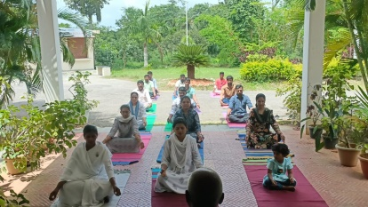
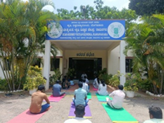
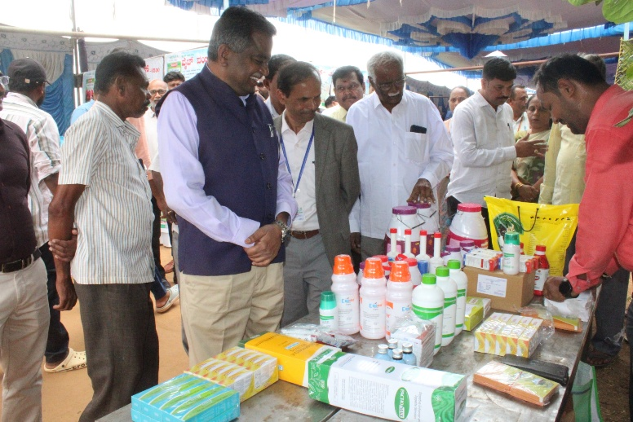 | 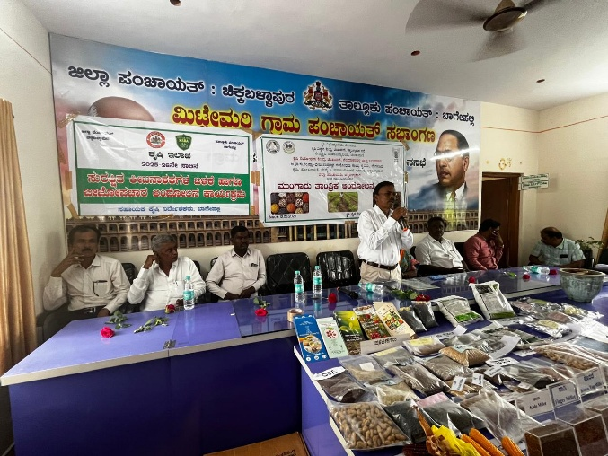
Vikasit Krishi Sankalp Abhiyan @ KVK, Bangalore Rural | Vikasit Krishi Sankalp Abhiyan @ KVK, Chintamani
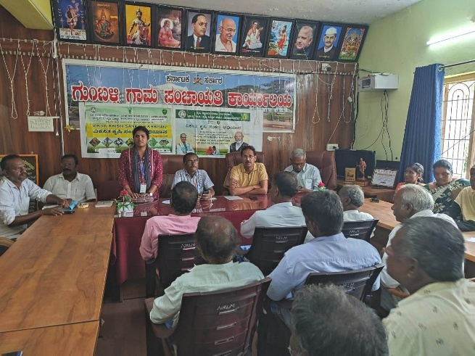 | 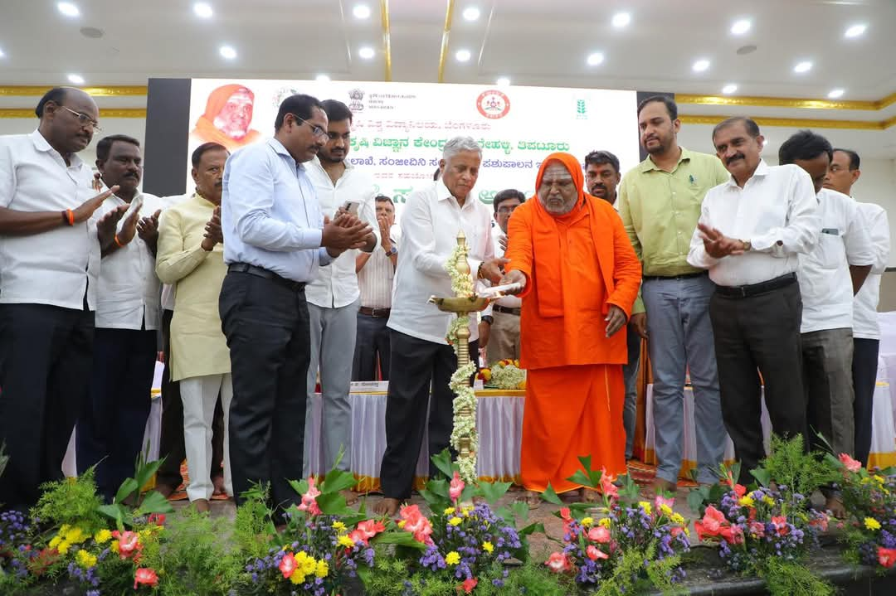
Vikasit Krishi Sankalp Abhiyan @ KVK, Chamarajnagar | Vikasit Krishi Sankalp Abhiyan @ KVK, Tumakuru

The KVK Ramanagar staff participated in the Yoga day celebration in the office premices

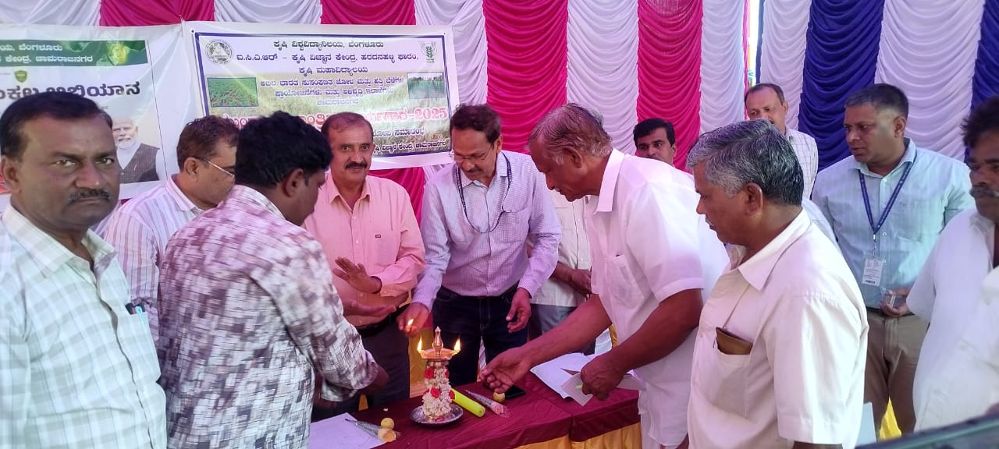  Inauguration of Kharif Technical Campaign-2025 by the dignitaries at KVK – Bangalore Rural & Chamarajanagar on 12-06-2025 |   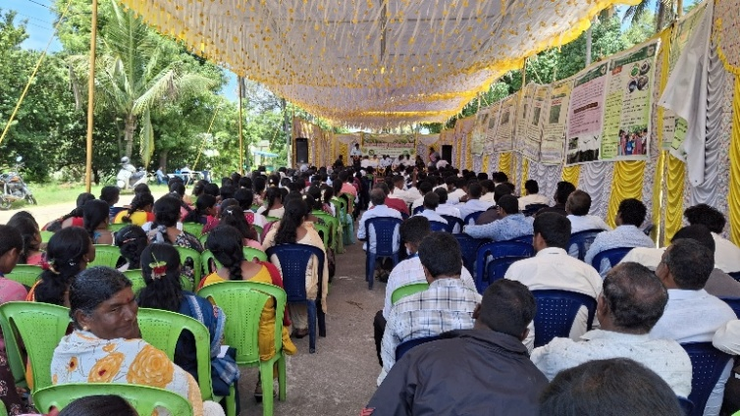  Kharif Technical Campaign – 2025 at EEU – Mysore on 12.06.2025

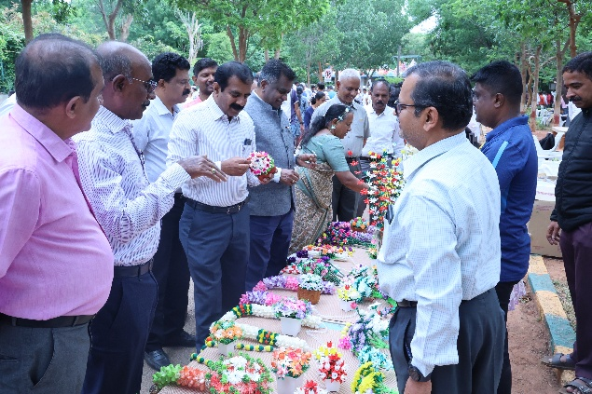  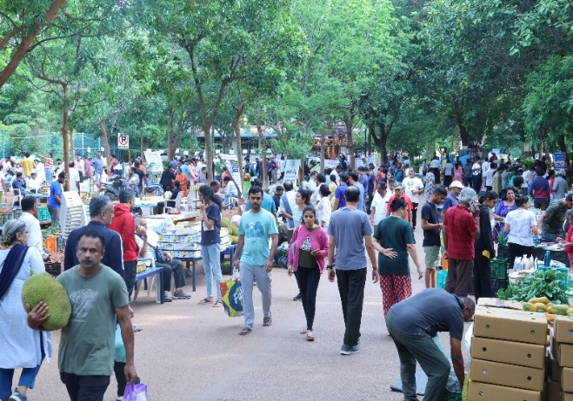 | 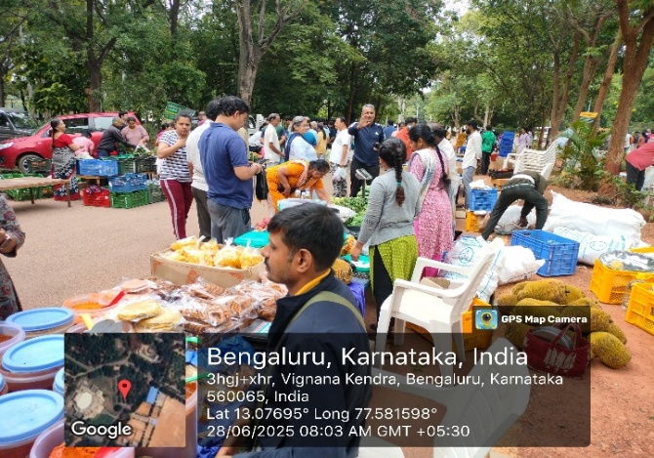  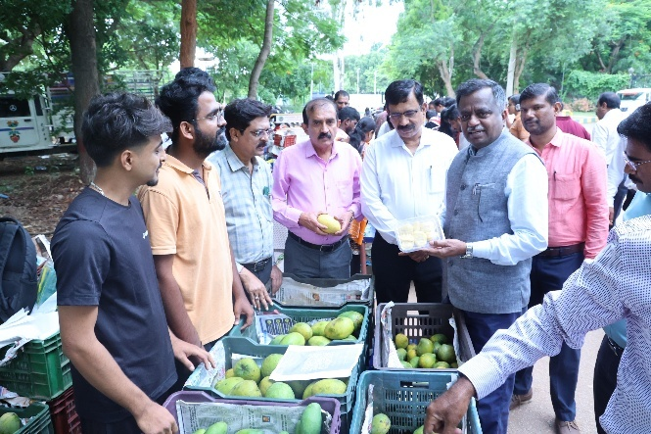
Glimpses of Raitha Santhe

VI. News Paper Coverage
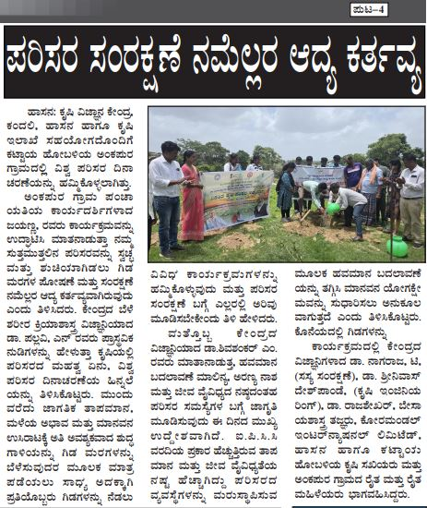  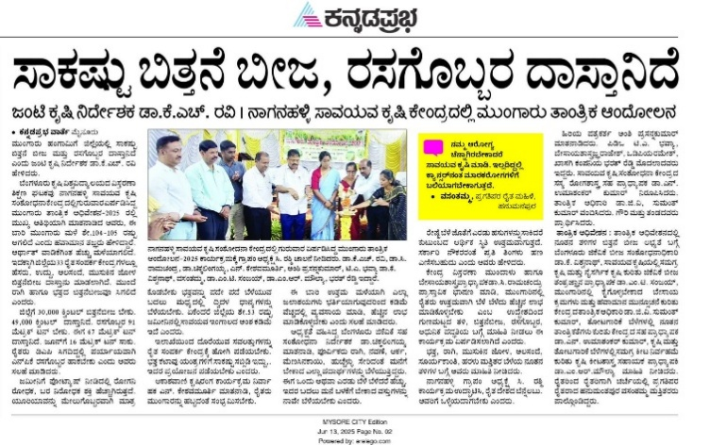  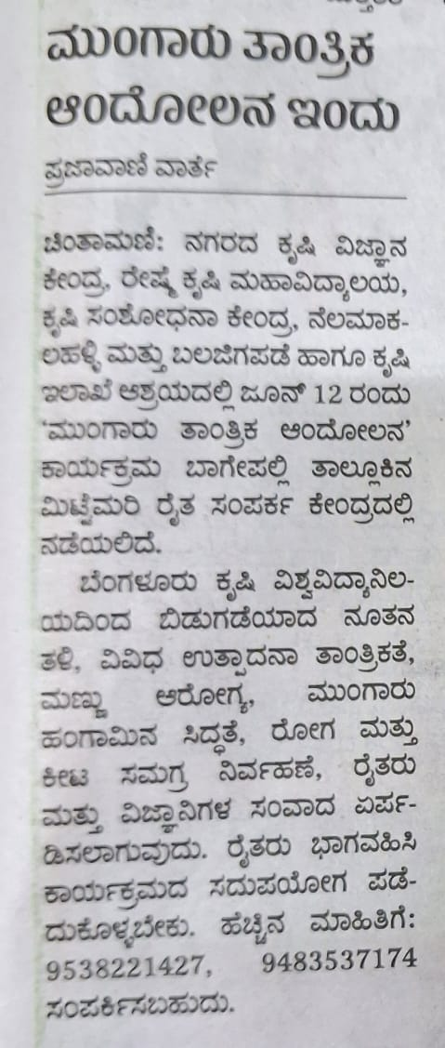  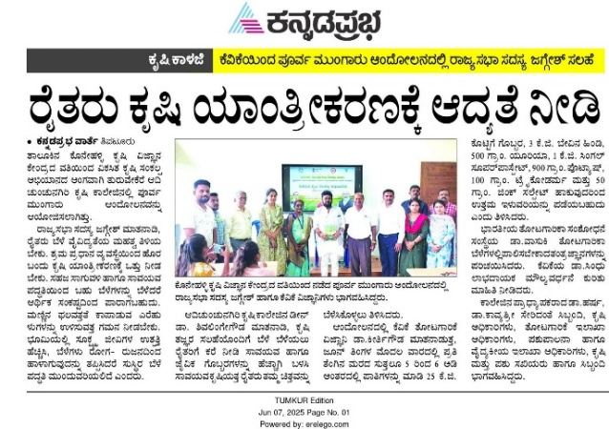 | 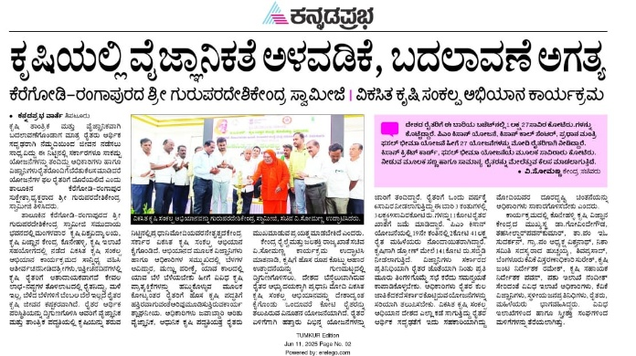  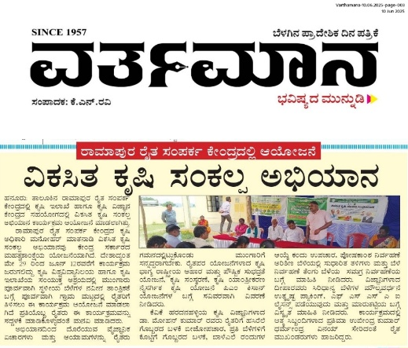  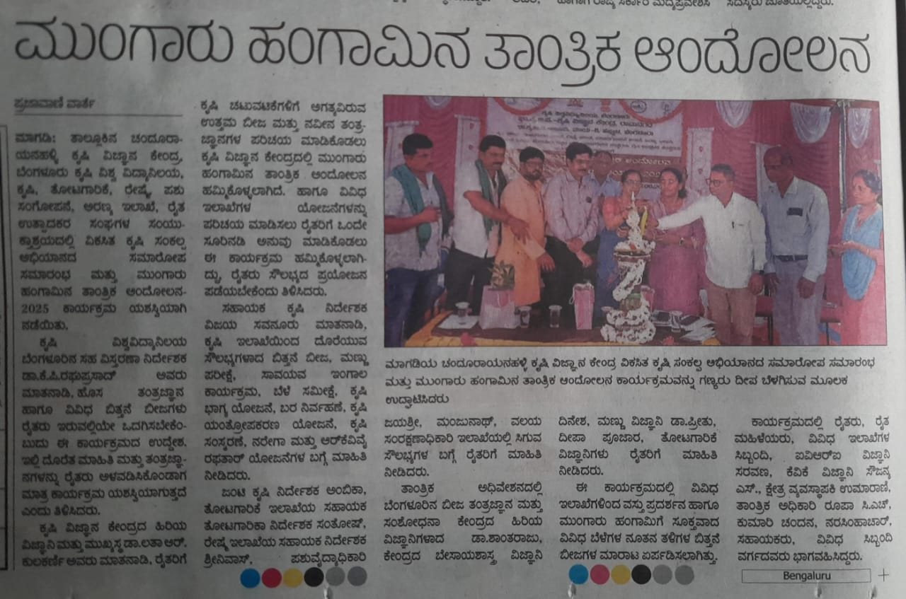

Sd/-
Director of Extension

